**Project Jugaad**

**A PROJECT REPORT**

**for**

**Mini Project (KCA353)**

**Session (2024-25)**

**Submitted by**

**Harshit Shekhar**

**2300290140073**

**Piyush Pratap Singh**

**2300290140116**

**Harsh Chaudhary**

**2300290140067**

**Submitted in partial fulfilment of the**

**Requirements for the Degree of**

**MASTER OF COMPUTER APPLICATION**

**Under the Supervision of**

**Dr. Akash Rajak**

### Professor



**Submitted to**

**Department Of Computer Applications**

**KIET Group of Institutions, Ghaziabad**

**Uttar Pradesh-201206**

**December 2024**

**CERTIFICATE**

Certified that Harshit Shekhar 2300290140073, Piyush Pratap Singh 2300290140116, Harsh Chaudhary 2300290140067 have carried out the project work having “**Project Jugaad**” (Mini-Project-KCA353) for Master of Computer Application from Dr. A.P.J. Abdul Kalam Technical University (AKTU) (formerly UPTU), Lucknow under my supervision. The project report embodies original work, and studies are carried out by the student himself/herself and the contents of the project report do not form the basis for the award of any other degree to the candidate or to anybody else from this or any other University/Institution.

**Dr. Akash Rajak**  **Dr. Arun Kumar Tripathi**

**Professor** **Dean (CA)**

**Department of Computer Applications** **Department of Computer Applications**

**KIET Group of Institutions, Ghaziabad** **KIET Group of Institutions, Ghaziabad**

**Project Jugaad**

**ABSTRACT**

Project Jugaad is a collaborative platform designed to address the daily needs of students and faculty by enabling the renting and sharing of essential items within a secure institutional network. With a strong emphasis on sustainability and community engagement, the platform provides an intuitive user experience powered by modern web technologies.

Key advancements in Project Jugaad include a user-friendly interface with responsive design for seamless use across web platforms, enhanced security through robust authentication mechanisms using bcrypt and JWT to ensure secure user data, and a personalized experience featuring user profiles, notifications, and customizable options for improved usability.

Additionally, efficient data handling is achieved with MongoDB-powered filtering and storage, ensuring optimized performance. By fostering resource sharing and efficient communication, Project Jugaad redefines peer-to-peer collaboration within academic communities, creating a sustainable and productive environment.

**ACKNOWLEDGEMENTS**

Success in life is never attained single-handedly. My deepest gratitude goes to my project supervisor, **Dr. Akash Rajak** for his guidance, help, and encouragement throughout my project work. Their enlightening ideas, comments, and suggestions.

Words are not enough to express my gratitude to **Dr. Arun Kumar Tripathi**,Dean (CA),Department of Computer Applications, for his insightful comments and administrative help on various occasions.

Fortunately, I have many understanding friends, who have helped me a lot on many critical conditions.

Finally, my sincere thanks go to my family members and all those who have directly and indirectly provided me with moral support and other kind of help. Without their support, completion of this work would not have been possible in time. They keep my life filled with enjoyment and happiness.

**HARSH CHAUDHARY**

**HARSHIT SHEKHAR**

**PIYUSH PRATAP SINGH**

**…………**

**TABLE OF CONTENT**

|  |  |  |  |  |  |  |
| --- | --- | --- | --- | --- | --- | --- |
|  | **Title** | | | | | **Page No** |
|  | Certificate | | | | | 2 |
|  | Abstract | | | | | 3 |
|  | Acknowledgements | | | | | 4 |
|  | Table of Contents | | | | | 5-7 |
|  | List of Tables | | | | | 8 |
|  | List of Figures | | | | | 9 |
| 1 | Introduction | | | | | 10-20 |
|  | 1.1 | Overview | | | | 10 |
|  |  | 1.1.1 | Features of Project Jugaad | | | 12 |
|  |  | 1.1.1.1 | User Authentication and Security | | 12 | | |
|  |  | 1.1.1.2 | Responsive Design | | 13 | | |
|  |  | 1.1.1.3 | Backend Handling with NodeJS and ExpressJS | | 13 | | |
|  |  | 1.1.1.4 | Product Listing and Sharing | | 13 | | |
|  |  | 1.1.2 | Advantages of Project Jugaad | | | 14 |
|  |  | 1.1.2.1 | | Resource Optimization | 14 | | |
|  |  | 1.1.2.2 | | Cost Efficiency | 14 | | |
|  |  | 1.1.2.3 | | Community Building | 15 | | |
|  |  | 1.1.2.4 | | Easy Access and Time-Saving | 15 | | |
|  | 1.2 | Purpose and Scope | | | | 15-17 |
|  |  | 1.2.1 | Objectives | | | 15-16 |
|  |  | 1.2.2 | Challenges Addressed | | | 16-17 |
|  | 1.3 | User Experience (UX) Approach | | | | 17-18 |
|  | 1.4 | Key Technologies Used | | | | 18 |
|  | 1.5 | Future Enhancements | | | | 19-20 |
| 2 | Feasibility Study | | | | | 21-28 |
|  | 2.1 | Technical Feasibility | | | | 21 |
|  | 2.2 | Operational Feasibility | | | | 22 |
|  | 2.3 | Economic Feasibility | | | | 22-23 |
|  | 2.4 | Risk Analysis | | | | 23-26 |
|  |  | 2.4.1 | Types of Risks | | | 23 |
|  |  | 2.4.1.1 | | Technical Risks | 23 | | |
|  |  | 2.4.1.2 | | Operational Risks | 23 | | |
|  |  | 2.4.1.3 | | Economic Risks | 23 | | |
|  |  | 2.4.1.4 | | Legal and Compliance Risks | 23 | | |
|  |  | 2.4.1.5 | | Market Risks | 24 | | |
|  |  | 2.4.2 | Risk Assessment Matrix | | | 24 |
|  |  | 2.4.3 | Mitigation Strategies | | | 25 |
|  |  | 2.4.3.1 | | Technical Risks Mitigation | 25 | | |
|  |  | 2.4.3.2 | | Operational Risks Mitigation | 25 | | |
|  |  | 2.4.3.3 | | Economic Risks Mitigation | 25 | | |
|  |  | 2.4.3.4 | | Legal and Compliance Risks Mitigation | 25 | | |
|  |  | 2.4.3.5 | | Market Risks Mitigation | 26 | | |
|  | 2.5 | Summary of Findings | | | | 27-28 |
|  | 3 | Design | | | | 29-42 |
|  |  | 3.1 | Frontend Architecture | | | 29-39 |
|  |  | 3.2 | Backend Architecture | | | 40-42 |
|  | Bibliography | | | | | 43 |
|  | Conclusion | | | | | 44 |

**LIST OF TABLES**

|  |  |  |
| --- | --- | --- |
| **Table No.** | **Name of Table** | **Page** |
| 1.1 | Cost Analysis | 28 |
| 1.2 | Technical Requirements | 26 |
| 1.3 | User Feedback Summary | 42 |

**LIST OF FIGURES**

|  |  |  |
| --- | --- | --- |
| 1.1 | Project Jugaad Workflow Diagram | 11 |
| 1.2 | Home Page | 12 |
| 1.3 | Data Flow Diagram | 19 |
| 1.4 | Entity Relationship Diagram | 21 |
| 3.1 | Category Page - ALL | 32 |
| 3.2 | About Us Page | 32 |
| 3.3 | Login Page | 33 |
| 3.4 | Signup Page | 34 |
| 3.5 | Profile Page | 34-35 |
| 3.6 | Why Us Page | 35 |
| 3.7 | Category Page - Clothes | 36 |
| 3.8 | Add a new Request UI | 36 |
| 3.9 | View Jugaad Request UI | 36 |
| 3.10 | Category Page - Bike | 38 |
| 3.11 | Category Page - Car | 38 |
| 3.12 | Category Page - Projects | 39 |
| 3.13 | Category Page - PG Rooms | 39 |
| 3.14 | Category Page - Books | 40 |
| 3.15 | Category Page - Essentials | 40 |
| 3.16 | Transaction Report UI | 41 |

**CHAPTER 1**

**INTRODUCTION**

### 1.1 Overview

Resource sharing plays a crucial role in fostering collaboration and efficiency in the dynamic world of academic communities. Students and faculty often require a platform to share daily-use essentials, exchange items, and communicate seamlessly within a secure network. Traditional methods, such as verbal coordination or fragmented systems, are often inefficient and lack scalability.

Project Jugaad addresses these challenges by providing an innovative platform that simplifies real-time resource sharing and communication. Built using the MERN stack, it integrates modern web technologies to create a streamlined and user-friendly experience.

The Project Jugaad has the following key features:

* Interactive platform to showcase the various requests posted by the user.
* A fast way to manage the reports is by the admin.
* The easy way to handle the payments.
* React to handle a single-page application.
* MongoDB to handle the databases.
* Only the people who have the KIET email ID can only login and register.

**Workflow of Project Jugaad**

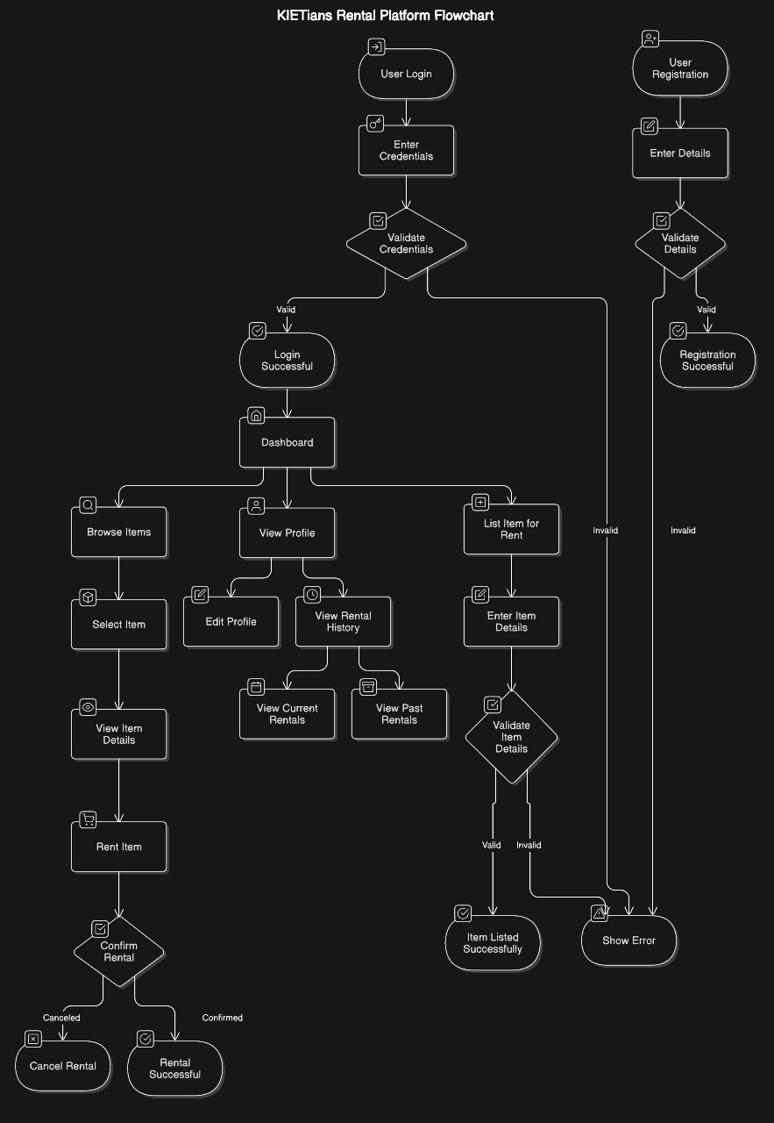

### 1.1.1 Features of Project Jugaad

Project Jugaad offers a range of features that make it stand out as a collaborative platform for students and faculty. These features are designed to enhance productivity, streamline workflows, and improve communication within the community.

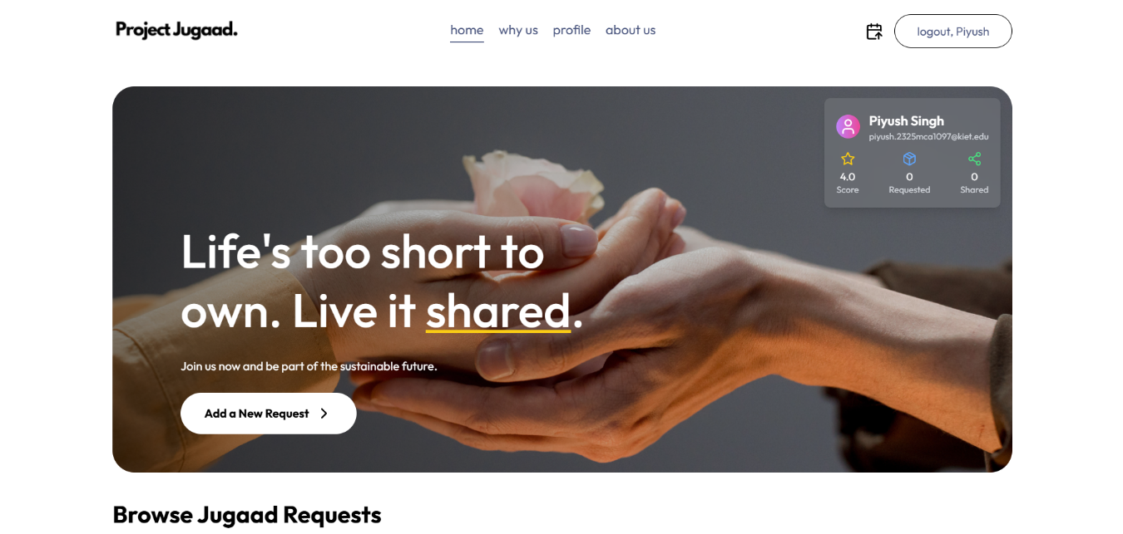

#### Home Page

#### **1.1.1.1 User Authentication and Security**

#### The user authentication and security in Project Jugaad are designed to ensure a safe and trustworthy environment for users. The system employs robust mechanisms such as bcrypt for hashing passwords, ensuring that sensitive user data remains encrypted and secure from unauthorized access. Additionally, JSON Web Tokens (JWT) are utilized for managing authentication and authorization, enabling secure communication between the client and server. This approach ensures that only verified users can access and interact with the platform. Together, these measures provide a seamless and secure login and registration process while safeguarding user data against potential threats**.**

#### **1.1.1.2 Responsive Design**

The **responsive design** of Project Jugaad ensures that users can access the platform from a wide range of devices, including desktops, tablets, and smartphones. The design adapts to different screen sizes and orientations, ensuring the platform’s functionality and usability are not compromised, regardless of the device being used.

This feature is particularly important for developers who may need to access the platform from various locations and devices:

* **Desktop Version**: Ideal for coding and debugging, with a large screen and full-featured interface.
* **Mobile Version**: For on-the-go updates or quick checks, the mobile interface provides a simplified yet efficient version of the platform.
* **Tablet Version**: A hybrid of the desktop and mobile experience, offering a balance between functionality and portability.

The design uses modern CSS frameworks such as **TailwindCSS** to ensure that elements are automatically adjusted based on the screen size. This ensures that Project Jugaad remains accessible and user-friendly across various devices and environments.

#### **1.1.1.3 Backend handled using Node and ExpressJS**

This feature highlights the **server-side technology stack** used to power the backend of **Project Jugaad**. Here's what it entails:

* **Node.js**:
  + A runtime environment that allows JavaScript to be executed on the server side.
  + Known for its non-blocking, event-driven architecture, it ensures fast and scalable performance.
  + Ideal for handling multiple simultaneous requests, which is crucial for applications like Project Jugaad.
* **Express.js**:
  + A lightweight and flexible web application framework built on top of Node.js.
  + Simplifies the creation of APIs, routing, and middleware for handling HTTP requests.
  + Provides robust tools for developing dynamic, data-driven web applications.

#### **1.1.1.4 Product Listing and Sharing**

The **product listing and sharing** feature in **Project Jugaad** facilitates a streamlined process for users to rent and share items within a trusted community. Users can easily upload and manage product listings, complete with descriptions, images, and relevant details, ensuring transparency and clarity. The platform incorporates advanced filtering and categorization options, enabling users to quickly find items that meet their needs. This feature fosters a collaborative environment where students and faculty can share daily-use essentials and other products efficiently, reducing wastage and promoting resource-sharing within the community.

### 1.1.2 Advantages of Project Jugaad

Here are some of the important advantages of Project Jugaad:

#### **1.1.2.1 Resource Optimization**

**Resource optimization** in **Project Jugaad** is centred around the idea of reducing waste and maximizing the utility of everyday items within a community. Instead of buying new products for short-term use, users can rent or share items with others, allowing for more efficient use of resources. This system reduces the need for constant production and consumption, which helps decrease the environmental footprint. By making essential products available for rent or sharing, users can enjoy the convenience of accessing items without the financial burden of ownership.

Additionally, **Project Jugaad** encourages a collaborative approach to resource management. Users can list their unused or seldom-used items, making them available to others who may need them. This not only optimizes the use of existing products but also creates a sense of community and trust among users. It empowers individuals to make smarter choices about consumption while fostering an environment where sharing is prioritized over unnecessary purchases, ultimately benefiting both users and the environment.

#### **1.1.2.2 Cost Efficiency**

**Cost efficiency** is a fundamental advantage of **Project Jugaad**, offering users a more affordable way to access products without the financial burden of ownership. Many items, such as electronics, appliances, or tools, are needed only occasionally, making their purchase an unnecessary expense. Through the platform, users can rent these products for short-term use, which significantly reduces costs. This is particularly beneficial for students and faculty who may not have the budget to purchase such items but still require access to them for specific needs, such as events or projects.

### Key Points on Cost-Efficiency:

* **Affordable Access**: Users can rent items instead of buying them, reducing the overall expenditure on products that are rarely used.
* **Savings on Ownership Costs**: Renting eliminates additional costs related to ownership, such as maintenance, storage, and depreciation.
* **Budget-Friendly for Students and Faculty**: The platform allows individuals with limited budgets to access essential products without significant financial strain.
* **Encourages Mindful Consumption**: Users only pay for the items they need when they need them, avoiding unnecessary purchases and promoting more sustainable consumption.

#### **1.1.2.3 Community Building**

**Community building** is a core principle of **Project Jugaad**, as the platform is designed to foster a sense of collaboration and trust among its users. By creating a space where students and faculty can share and rent products, the platform encourages individuals to engage with one another, strengthen their relationships, and work together toward a common goal of resource optimization. The closed-circle approach ensures that users are interacting within a trusted network, making the sharing process safer and more reliable. This builds a strong sense of community, where people are motivated to help one another and share resources for mutual benefit.

Through **Project Jugaad**, users are not just renting or sharing items; they are also contributing to a culture of cooperation and mutual support. By promoting sharing, the platform encourages users to connect with others who have similar needs, ultimately enhancing communication and fostering long-lasting relationships. This creates an environment where users feel part of something larger than just a transaction, building a network of trust and camaraderie within the community. As the platform grows, the sense of belonging and collective responsibility strengthens, enriching the experience for all participants.

#### **1.1.2.4 Easy Access and Time Saving**

**Easy access** and **time-saving** are significant advantages of **Project Jugaad**, as the platform is designed to streamline the process of renting and sharing products. The user interface is simple and intuitive, making it easy for users to browse, list, and rent items without any complex procedures. With a well-organized layout and efficient search features, users can quickly find the products they need, minimizing the time spent searching for items. Additionally, the platform's mobile-friendly design ensures that users can access it from anywhere, making it convenient for on-the-go usage.

In terms of **time-saving**, the advanced filtering and categorization options allow users to narrow down their choices swiftly, eliminating the need to sift through irrelevant listings. Once an item is selected, the rental process is fast and seamless, reducing delays. Furthermore, **Project Jugaad** provides real-time notifications about new listings and updates, keeping users informed instantly about available products, so they don’t miss out on any opportunities. This combination of easy access and time-saving features ensures that users can efficiently meet their needs without wasting time or effort.

#### **1.2.1 Objectives**

The specific objectives of Project Jugaad include:

* **Promote Resource Sharing**: Encourage the sharing and renting of daily-use essentials within a trusted community to optimize the use of available resources.
* **Reduce Waste**: Minimize unnecessary consumption and waste by promoting the rental or sharing of items instead of purchasing new ones.
* **Foster Collaboration**: Build a collaborative environment where students and faculty members can support each other by sharing products and resources.
* **Ensure Security**: Provide a safe platform with secure user authentication, ensuring that only verified users can participate in rentals and transactions.
* **Offer Cost-Effective Solutions**: Help users save money by providing an affordable alternative to buying items that are needed temporarily.
* **Enhance Accessibility**: Make essential products easily accessible to users by offering a simple and intuitive platform for browsing, renting, and sharing.
* **Create a Sense of Community**: Strengthen relationships and build trust among users by promoting interaction and cooperation within a closed network.
* **Support Sustainability**: Contribute to environmental sustainability by reducing the demand for new products and encouraging the reuse of existing ones.

#### **1.2.2 Challenges Addressed**

Here are the various challenges addressed by Project Jugaad:

**Underutilization of Resources**:

* Many items, such as tools, appliances, and books, are purchased but rarely used. Project Jugaad addresses this by providing a platform to share or rent these items, ensuring optimal utilization.

**High Costs for Temporary Needs**:

* Buying products for short-term use can be expensive. The platform allows users to rent items, reducing the financial burden and making essential products more accessible.

**Limited Access to Resources**:

* Students and faculty often lack access to specific items when needed. Project Jugaad solves this by offering a centralized platform where users can find and borrow products easily.

**Trust Issues in Transactions**:

* Sharing and renting require a level of trust between users. The platform ensures secure transactions through user authentication, fostering confidence within the community.

**Time-Consuming Search for Products**:

* Finding specific items can be time-consuming. With advanced filtering and categorization, users can quickly locate what they need.

**Lack of Community Engagement**:

* Traditional platforms focus on transactions rather than relationships. Project Jugaad emphasizes community building, encouraging users to interact and support each other.

**Environmental Waste**:

* Excessive purchasing leads to waste and environmental harm. The platform promotes sustainable practices by encouraging reuse and sharing.

**Difficulty in Managing Inventory**:

* Users may struggle to keep track of their listed or borrowed items. The platform offers user-friendly tools for managing listings and rentals.

### 1.3 User Experience (UX) Approach

Project Jugaad places significant emphasis on providing a **smooth and intuitive user experience (UX)**. The UX design is centered around usability, simplicity, and customization:

**User-Centric Design**:

* The platform is built with a focus on the needs and behaviors of its users, ensuring an intuitive and enjoyable experience. User feedback is continuously gathered to refine and improve functionality.

**Simple and Intuitive Interface**:

* A clean and minimalistic interface ensures that users can easily navigate the platform, browse items, and manage their listings without technical expertise.

**Responsive Design**:

* The platform is optimized for all devices, including desktops, tablets, and smartphones, ensuring seamless access regardless of the user’s preferred device.

**Personalized User Profiles**:

* Each user has a customizable profile to manage their listed items, rentals, and interactions, creating a sense of ownership and personalization.

**Secure and Trustworthy Environment**:

* Strong authentication and secure data handling build trust, providing users with a safe and reliable platform for transactions.

**Community Engagement Tools**:

* Features like reviews, ratings, and in-app messaging foster interaction and trust among users, enhancing the sense of community.

### 1.4 Key Technologies Used

Project Jugaad leverages modern technologies to provide a scalable, efficient, and robust platform:

* **React** for frontend development, ensuring a modular and responsive user interface.
* **Node.js** and **Express.js** for backend development, allowing real-time data processing and handling of multiple concurrent users.
* **MongoDB** for storing project data, ensuring flexibility and scalability in handling large datasets.
* **TailwindCSS** for designing the webpages and improving their styles

These technologies ensure that Project Jugaad can handle large volumes of real-time interactions, scale efficiently as the user base grows, and provide a seamless user experience.

**Data Flow Diagram**

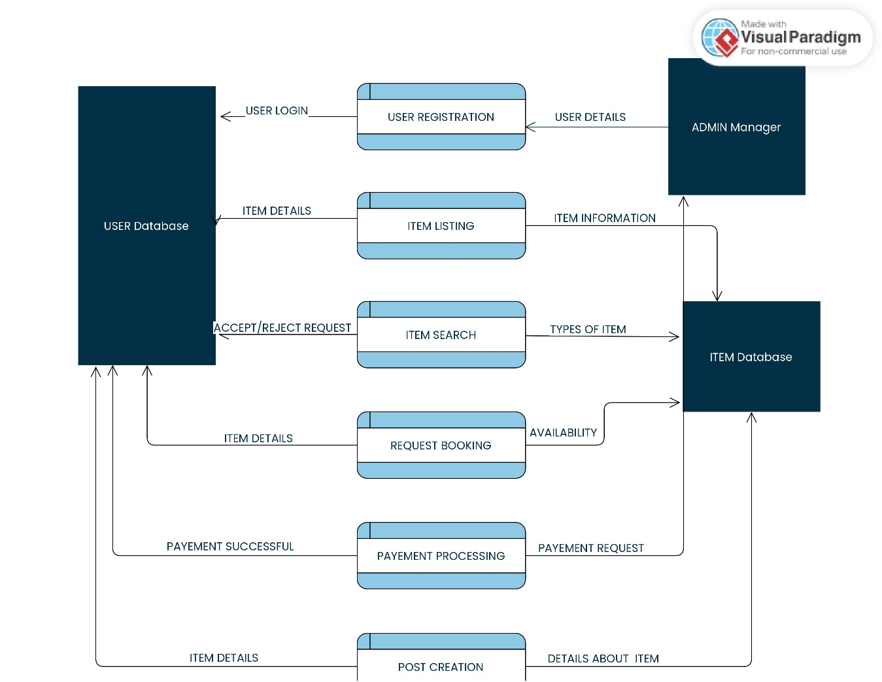

**1.5 Future Enhancements**

Future updates to **Project Jugaad** will focus on expanding its capabilities and improving the user experience:

**Mobile Application**:

* Develop a dedicated mobile app for Android and iOS to improve accessibility and enhance user convenience.

**AI-Powered Recommendations**:

* Implement AI-based recommendation systems to suggest relevant products to users based on their preferences, past searches, and browsing history.

**Integrated Payment Gateway**:

* Add secure payment options for seamless and hassle-free transactions directly through the platform.

**Enhanced Security Features**:

* Introduce multi-factor authentication (MFA) and additional encryption measures to further secure user accounts and data.

**Gamification Elements**:

* Include features like badges, points, and leaderboards to encourage active participation and make the platform more engaging.

**Community Forums and Discussion Boards**:

* Create spaces for users to interact, share tips, and discuss product usage or availability, enhancing community engagement.

**Subscription Plans**:

* Offer premium subscription models with benefits like priority listing, additional visibility for items, and early access to new features.

**Item Delivery and Pickup Services**:

* Partner with logistics providers to facilitate item delivery and pickup, making the rental process even more convenient.

**Expanded User Analytics**:

* Provide users with insights into their activity, such as items frequently rented, income earned from sharing, or money saved by renting instead of buying.

**Integration with Sustainable Practices**:

* Collaborate with sustainability initiatives to promote eco-friendly products and practices, aligning the platform with global sustainability goals.

**Language and Localization Support**:

* Add support for multiple languages and regional preferences to make the platform accessible to a broader audience.

**Entity Relationship Diagram**

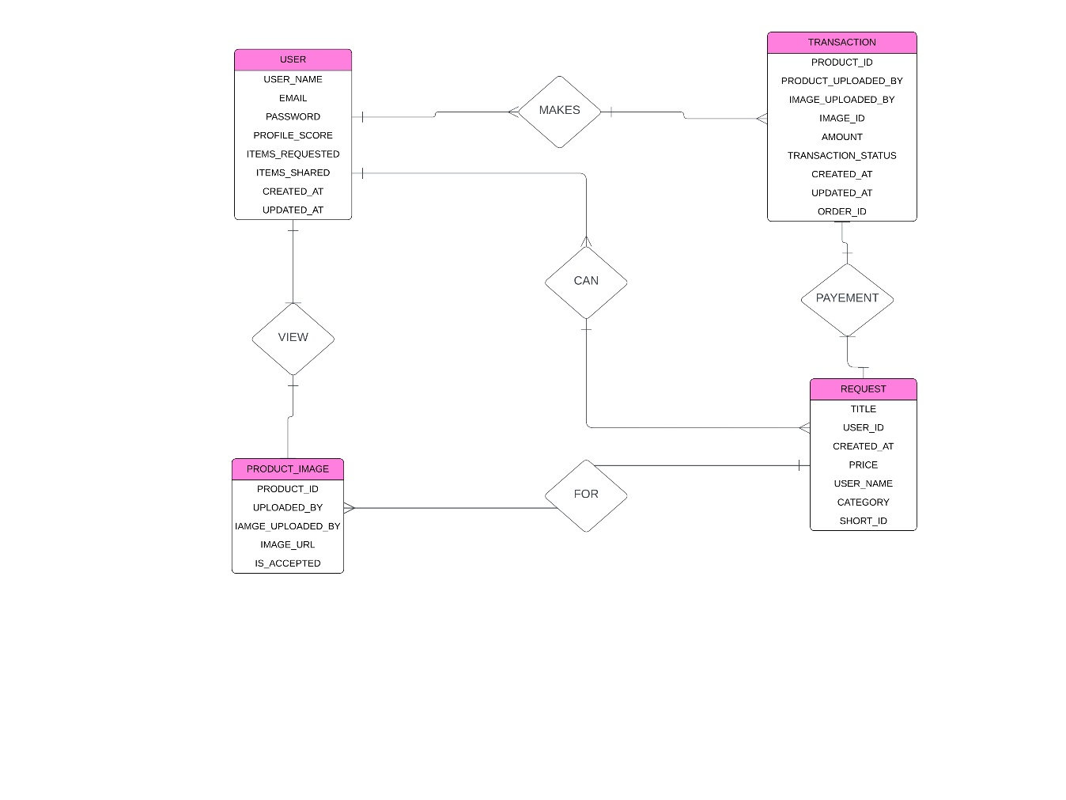

**CHAPTER 2**

**Feasibility Study**

A feasibility study is a detailed analysis that examines a proposed project's critical aspects to determine its likelihood of success. It can help identify potential challenges, such as logistical, financial, and market issues. A feasibility study can also help determine if a project should proceed, and if so, it can produce a project plan and budget estimates.

### 2.1 Technical Feasibility

The **technical feasibility** of **Project Jugaad** focuses on the practical aspects of the project’s technology stack, its scalability, performance requirements, and the potential challenges in its development and deployment.

#### **Technology Stack:**

**Technology Stack (MERN)**:

* The platform's core structure is built on the **MERN stack** (MongoDB, ExpressJS, React, NodeJS), which is a proven, scalable, and efficient technology stack for web applications.
  + **MongoDB** provides flexible, scalable, and document-oriented data storage, making it suitable for managing user profiles, product listings, and transactions.
  + **ExpressJS** ensures smooth handling of HTTP requests and routes the API calls efficiently.
  + **ReactJS** enables a responsive and dynamic user interface, which is essential for a seamless user experience.
  + **NodeJS** allows for high-speed, non-blocking I/O operations, making it ideal for managing multiple concurrent requests.

**Authentication and Security**:

* **JWT (JSON Web Tokens)** for secure user authentication ensures that each user’s session is authenticated and that unauthorized access is blocked.
* **bcrypt** provides strong encryption for passwords, ensuring that user data is protected.
* **OAuth 2.0** or **Multi-Factor Authentication (MFA)** can be integrated for enhanced security, especially for sensitive transactions or high-value items.**Data Scalability**:
* **MongoDB** is horizontally scalable, meaning as the platform grows, it can handle more data and users without compromising performance.

**UI/UX Design**:

* **ReactJS** ensures a modular, reusable UI design, making it easy to maintain and update.
* CSS frameworks like **TailwindCSS** or **Material UI** can be used for a consistent, responsive design across multiple devices (desktop, tablet, and mobile).

### 2.2 Operational Feasibility

The **operational feasibility** of Project Jugaad examines the ability of the system to be successfully implemented within existing operational environments and workflows.

**Platform Usability**:

* **User-Friendly Interface**: The platform will have a simple, intuitive, and easy-to-navigate interface. This will ensure that users of varying technical expertise can easily access and use the platform for listing and renting products. The ease of use will encourage higher adoption rates and reduce the chances of user frustration.
* **Mobile and Web Access**: Since the platform is accessible both on web browsers and mobile devices (through a responsive web design or mobile app), it will cater to a broader audience and ensure consistent access.

**Product Listing and Sharing Process**:

* **Simplified Listing Process**: Users can easily list their products on the platform with minimal steps. The backend will automate categorization, making the listing process smooth. This reduces the operational effort for the platform team and ensures that product listings are efficiently managed.

**Security and Risk Management**:

* **Authentication and User Verification**: User authentication systems using **JWT** and **bcrypt** help prevent unauthorized access and reduce security threats, contributing to the overall stability and safety of the platform.

### 2.3 Economic Feasibility

The **economic feasibility** section evaluates whether the benefits of implementing Project Jugaad outweigh the costs involved in its development, deployment, and maintenance.

**Initial Development Costs**:

* The platform's development leverages the **MERN stack**, which is open-source and cost-effective. There are no licensing fees, significantly reducing the upfront investment.

**User Acquisition Costs**:

* Initial marketing efforts may require investment in **social media campaigns**, **search engine marketing (SEM)**, and partnerships. However, these costs can be managed efficiently by targeting specific user demographics.
* Organic growth through word-of-mouth, coupled with a user-friendly interface and reliable service, reduces long-term marketing expenses.

**Cost Savings for Users**:

* The platform’s value proposition of reducing expenses by renting instead of buying ensures high user adoption and retention. Users save money, making the service economically appealing and justifying its cost.

### 2.4 Risk Analysis

Risk analysis helps identify potential challenges and issues that may arise during the development and deployment of **Project Jugaad**. The risks can be categorised into various types to assess their impact and likelihood and create mitigation strategies.

**2.4.1. Types of Risks:**

**2.4.1.1 Technical Risks**

* **Integration Issues**: Difficulties in integrating the frontend, backend, and database efficiently.
* **Scalability Concerns**: Handling a growing number of users and transactions without performance degradation.
* **Security Vulnerabilities**: Risks associated with unauthorized access, data breaches, or weak authentication mechanisms.

**2.4.1.2 Operational Risks**

* **User Adoption**: Users may find the system too complex or lack interest in using the platform.
* **Resource Availability**: Limited access to necessary tools, frameworks, or development resources.
* **Maintenance Challenges**: Continuous updates and bug fixes may become resource-intensive.

**2.4.1.3 Economic Risks**

* **Budget Overruns**: Development costs exceeding the allocated budget.
* **Revenue Generation**: Uncertainty in monetization models and profitability.

**2.4.1.4 Legal and Compliance Risks**

* **Regulatory Compliance**: Adhering to data protection laws like GDPR or local data regulations.
* **Copyright and Intellectual Property Issues**: Legal issues arising from user-generated content.

**2.4.1.5 Market Risks**

* **Competition**: Competing platforms may overshadow *Project Jugaad*.
* **Changing Trends**: User preferences or technological trends shifting during development.

**2.4.2 Risk Assessment Matrix**

|  |  |  |  |  |
| --- | --- | --- | --- | --- |
| **Risk Type** | **Impact** | **Likelihood** | **Priority** | **Mitigation Strategy** |
| Integration Issues | High | Moderate | High | Conduct thorough testing and use modular development. |
| Scalability Concerns | High | Moderate | High | Use cloud services and scalable architecture. |
| Security Vulnerabilities | Critical | Moderate | High | Implement robust security measures (e.g., bcrypt, JWT). |
| User Adoption | Medium | Moderate | Medium | Provide user training and simplify the UI/UX. |
| Budget Overruns | High | Low | Medium | Create a detailed cost plan and allocate a contingency. |
| Regulatory Compliance | High | Low | Medium | Regularly review and align with data protection laws. |

### 2.4.3 Mitigation Strategies

### 2.4.3.1 Technical Risks Mitigation

### Quality Assurance: Perform rigorous testing (unit, integration, and stress testing) to minimize bugs and performance issues.

### Scalable Design: Use scalable technologies like cloud-hosted databases (e.g., MongoDB Atlas) and load balancers.

### Regular Security Audits: Perform penetration testing and implement encryption for sensitive data.

### 2.4.3.2 Operational Risks Mitigation

### User Feedback Loop: Gather regular feedback from users during development and adapt features accordingly.

### Resource Planning: Ensure the availability of skilled developers and necessary tools in advance.

### 2.4.3.3 Economic Risks Mitigation

### Agile Development: Follow an iterative development model to ensure efficient resource usage.

### Funding Options: Explore funding from investors or grants for additional financial support.

### 2.4.3.4 Legal and Compliance Risks Mitigation

### Legal Counsel: Consult legal experts to ensure compliance with data and copyright laws.

### User Agreements: Draft clear terms and conditions to outline usage policies.

### 2.4.3.5 Market Risks Mitigation

### Competitive Analysis: Monitor competitors and innovate unique features.

### Marketing Efforts: Promote the platform to build user interest and adoption.

### 2.5 Summary of Findings

**2.5.1 Technical Feasibility**

The platform is built on the scalable and efficient MERN stack, ensuring robust performance and adaptability. It incorporates secure user authentication, cloud-based data storage, and integration with third-party services like payment gateways and logistics APIs. The planned mobile app using React Native ensures cross-platform compatibility, enhancing accessibility and future scalability.

Following is the Technical Requirements table:

|  |  |  |
| --- | --- | --- |
|  | Requirements | Details |
| Frontend | $$Framework$$ | React.js |
| $$Responsive Design Framework$$ | TailwindCSS |
| $$Routing$$ | React Router DOM |
| State Management | React Context API |
| API Integration | Axios |
| Browser Capability | Cross Browser Support\ |
| Backend | Framework | Node.js |
| Authentication | JSON WEB TOKENS |
| API Framework | Express.js |
| Database ORM | Mongoose |
| Image Storage | Cloudinary |
| Security | Bcrypt |
| Middleware | Custom (authentication, Multer) |
|  |  |  |
| Database | Type | NoSQL |
| Database | MongoDB |
| Data Handling | Schema for User, Products, Rentals, Transactions |
| Cloud Hosting | MongoDB Atlas |
|  |  |
|  |  |
|  |  |  |
| Development Tools | Version Control | Git/Github |
| IDE | VS CODE |
| Collaboration | Github Projects and Discord |

**2.5.2 Operational Feasibility**

Project Jugaad’s user-friendly interface, streamlined processes for product listing and sharing, and real-time communication features ensure a smooth user experience. The use of cloud-based solutions and third-party integrations minimizes operational complexity. Automated maintenance and support mechanisms enhance efficiency, while clear policies and security measures reduce risks.

**2.5.3 Economic Feasibility**

The project is cost-effective, leveraging open-source tools and cloud services to minimize development and operational expenses. Diverse revenue streams, such as transaction commissions, premium subscriptions, and advertisements, make it financially sustainable. With high user value in cost-saving and accessibility, the platform has strong potential for profitability within a short timeframe

Cost Estimation Table:

|  |  |  |  |
| --- | --- | --- | --- |
| **Category** | **Item** | **Cost (INR)** | **Details** |
| Development | Developer Salaries | 1,50,000 - 3,00,000 | Estimated for 3 developers over 3-4 months (Frontend, Backend, and Full Stack). |
| Development | UI/UX Design | 50,000 - 75,000 | Includes wireframing, prototyping, and creating design assets. |
| Hosting & Deployment | Application Hosting | 20,000 - 50,000 annually | Services like Render, Vercel, or AWS for hosting the web application. |
| Hosting & Deployment | Database Hosting | 15,000 - 30,000 annually | MongoDB Atlas for NoSQL database management. |
| Hosting & Deployment | Domain Name | 1,000 - 2,000 annually | Custom domain registration (e.g., .com, .in). |
| Hosting & Deployment | SSL Certificate | 500 - 2,000 annually | For HTTPS protocol and secure connections (often included in hosting packages). |
| Tools & Services | Image Hosting | 10,000 - 15,000 annually | Cloudinary for image uploads and storage. |
| Tools & Services | API Management | 5,000 - 10,000 annually | For managing API traffic (if using premium services). |
| Tools & Services | Version Control | Free - 10,000 annually | GitHub (Free for public repos, paid for private or team-based plans). |
| Testing & Maintenance | Testing Tools | 5,000 - 15,000 annually | Tools for unit testing, API testing, and end-to-end testing. |

**Conclusion:**

Project Jugaad is technically robust, operationally efficient, and economically viable. The project is well-equipped to meet user needs, scale effectively, and achieve long-term sustainability while offering significant value to its users.

**CHAPTER 3**

**Design**

The design of Project Jugaad focuses on creating a user-centric, scalable, and visually appealing platform. To ensure seamless functionality, it integrates intuitive user interfaces, responsive layouts, and secure back-end architecture. This chapter outlines the various design components, including system architecture, database design, user interface design, and data flow.

#### **3.1 Frontend Architecture**

The frontend architecture of Project Jugaad is designed to deliver a responsive, dynamic, and user-friendly experience. Built using **React.js**, the architecture emphasizes modularity, scalability, and reusability.

***3.*1.1 Key Components of the Frontend Architecture:**

3.1.1.1 Component-Based Structure

The front end is broken into small, reusable React components, each responsible for a specific functionality.

* **Atomic Design**: Implements atomic design principles with components categorized into:
  + **Atoms**: Small, fundamental components (e.g., buttons, input fields).
  + **Molecules**: Groups of atoms (e.g., search bars, product cards).
  + **Organisms**: Complex UI sections (e.g., product grids, user dashboards).
  + **Templates**: Page-level layouts combining organisms.
  + **Pages**: Complete web pages that assemble templates and handle routing.

**3.1.1.2 Routing**

**React Router DOM** is used for dynamic routing to ensure seamless navigation between pages.

All routes:

**/ → Homepage**



**/about → About Us Page**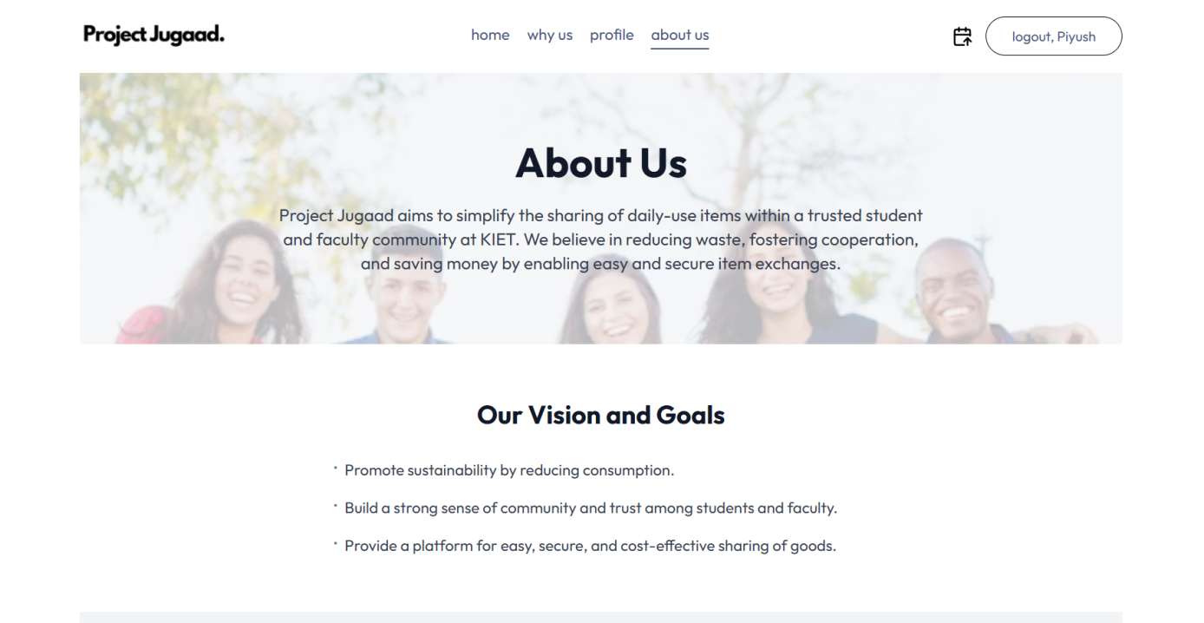

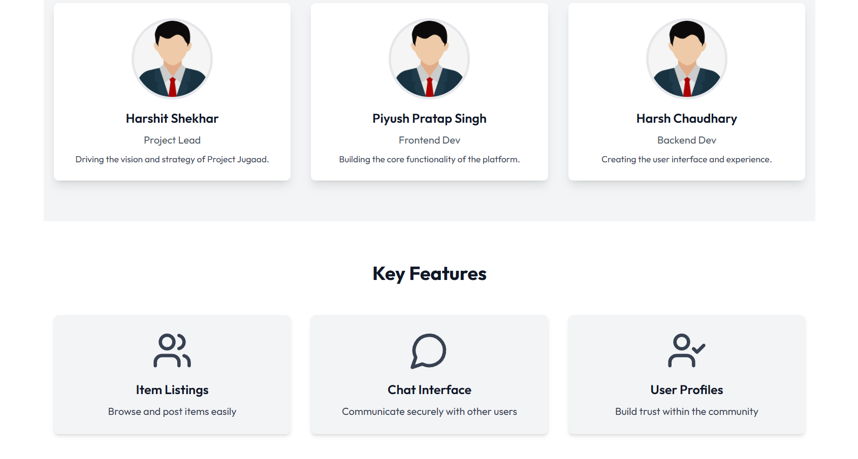

**/login → Login Page**

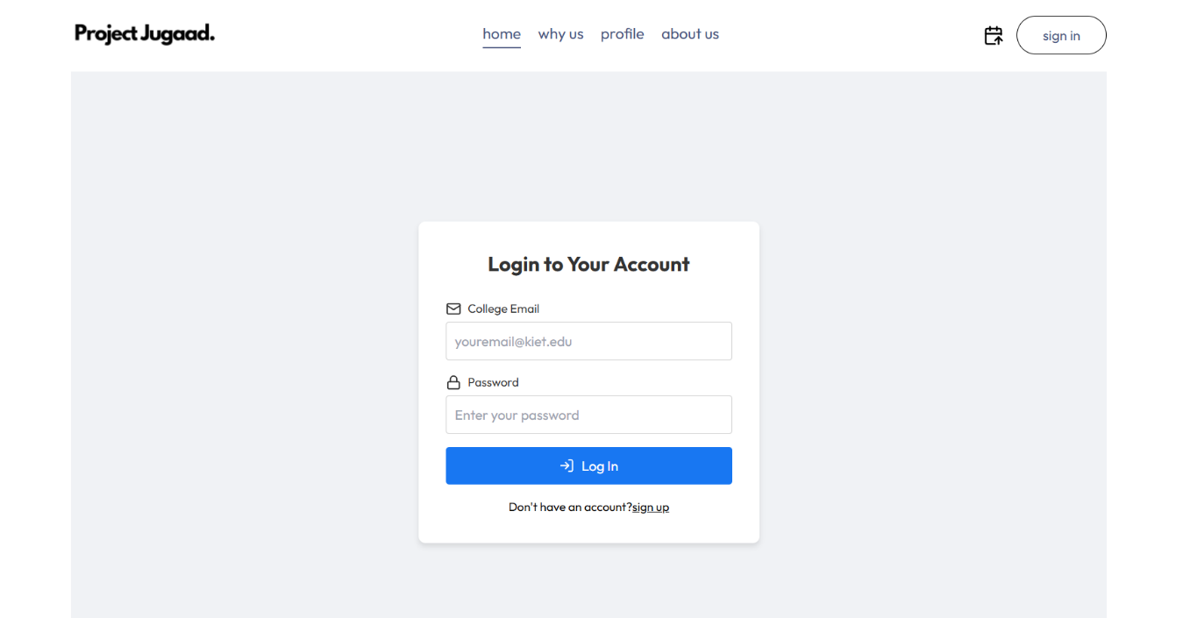

**/signup → Sign Up Page**

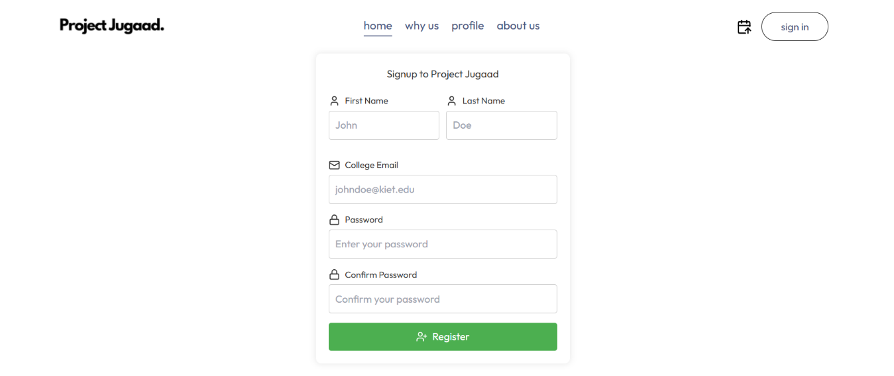

**/profile → Profile Page**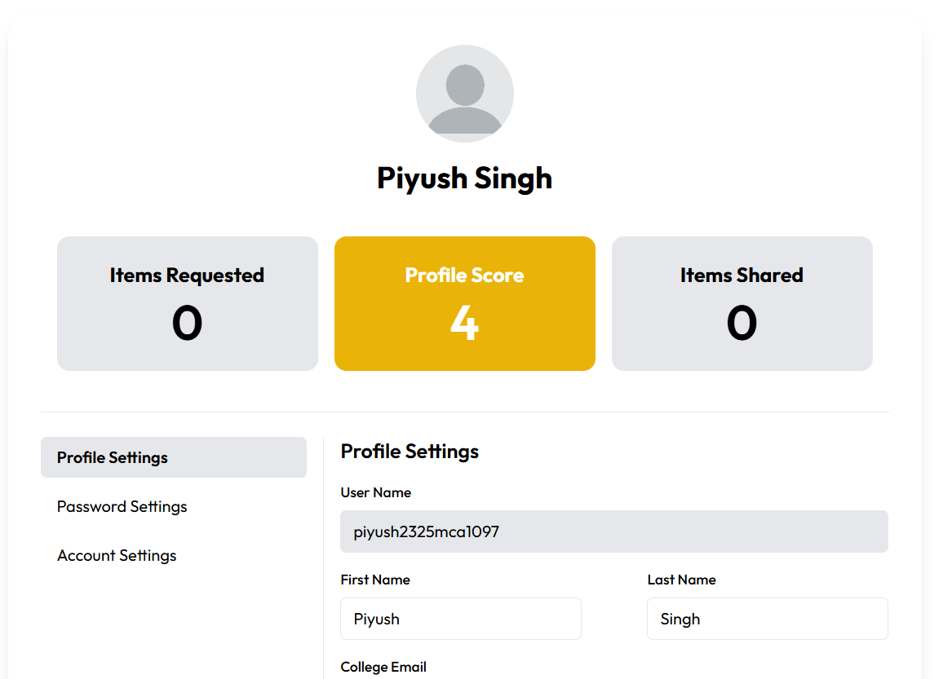

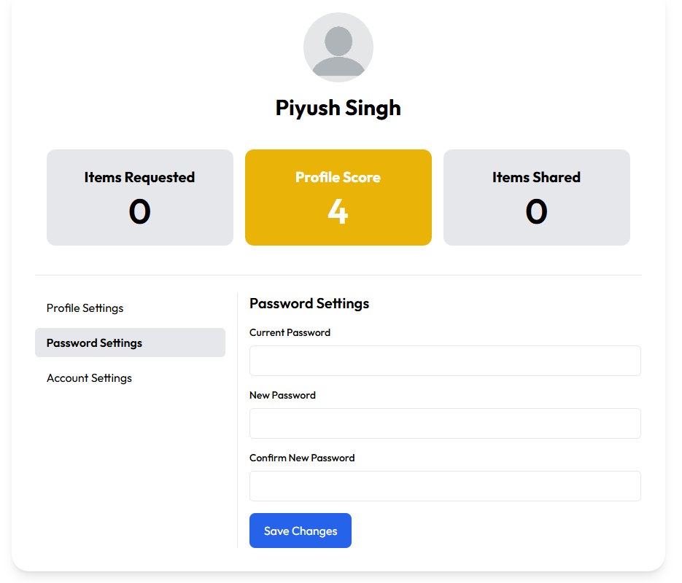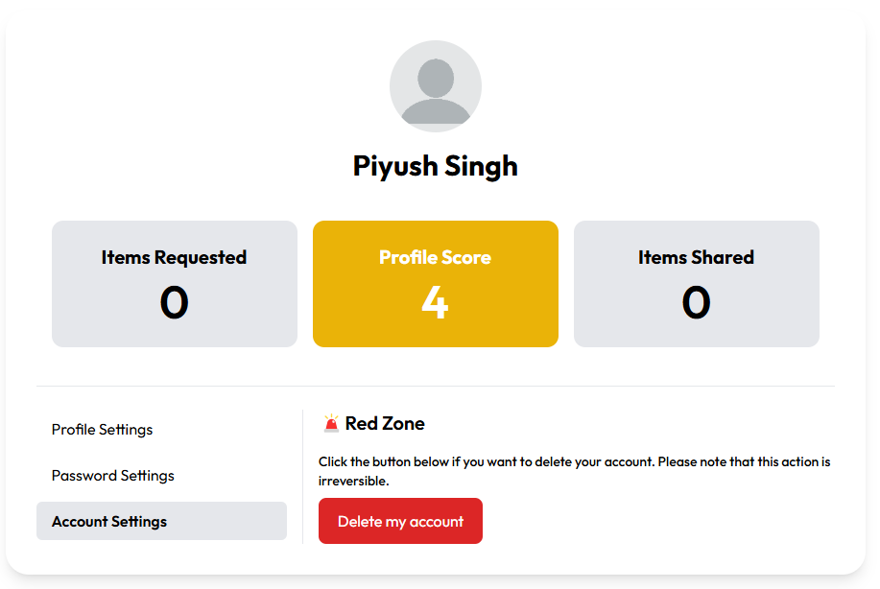

**/why-us → Why Us Page**

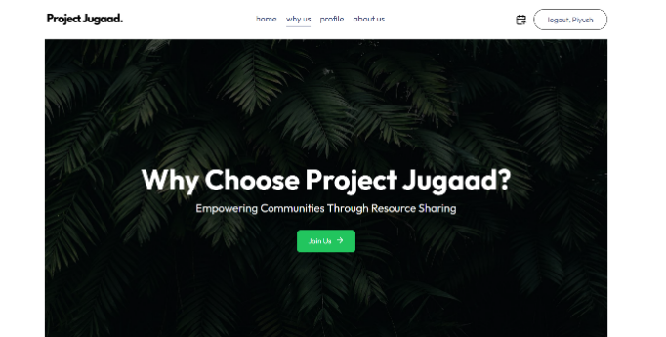

**/short/:id → Short ID Routing Page**

**/addRequest → Page for Adding Request Page**

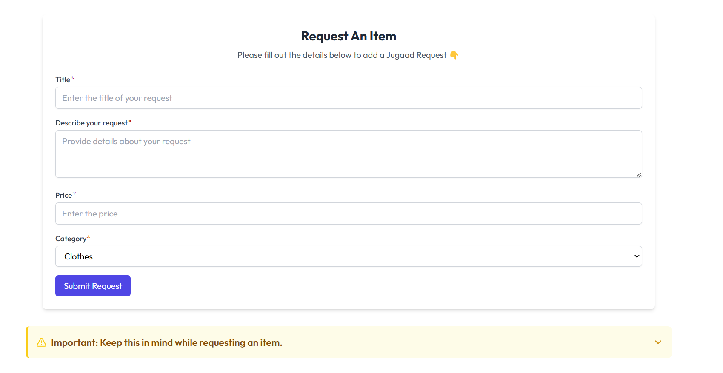

**/jugaad-req/:id → Jugaad Request Page**

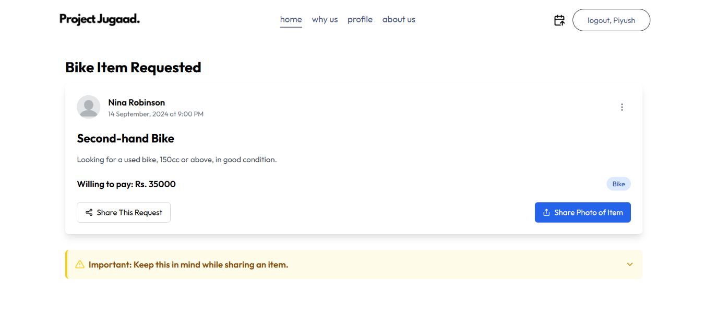

**/category/all**

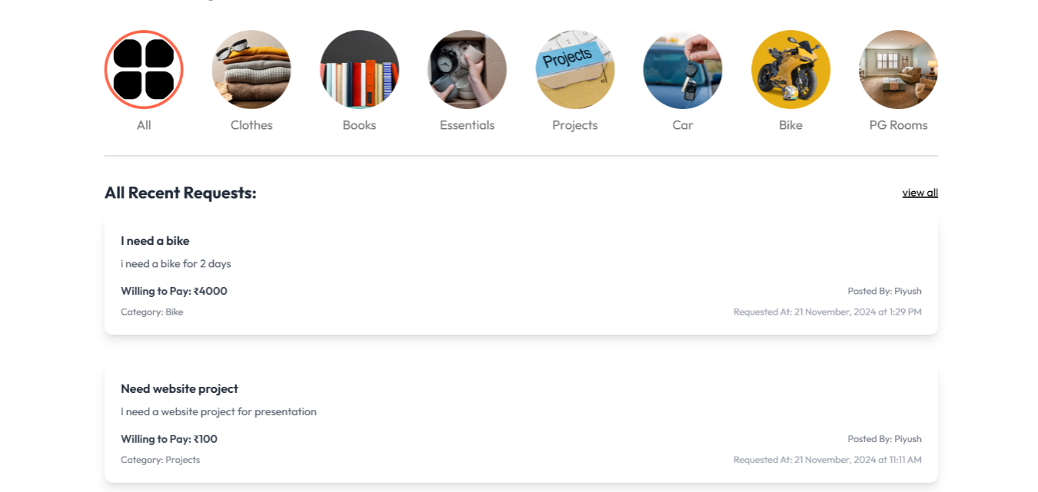

**/category/clothes → Category Item: Clothes**

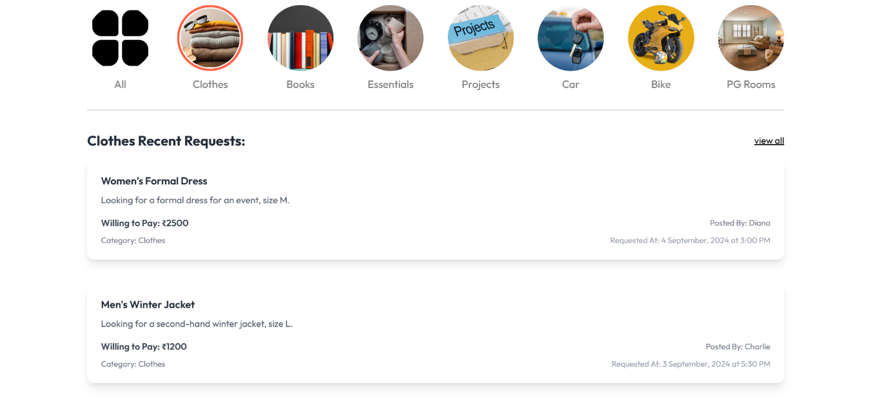

**/category/bike → Category Item: Bike**

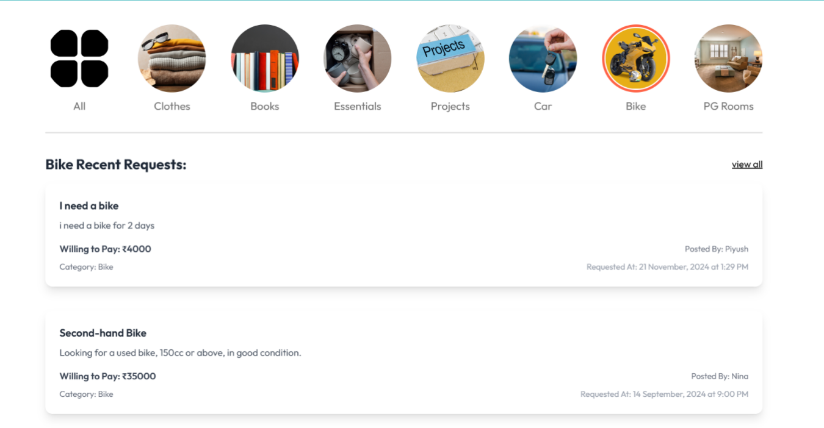

**/category/car → Category Item: Car**

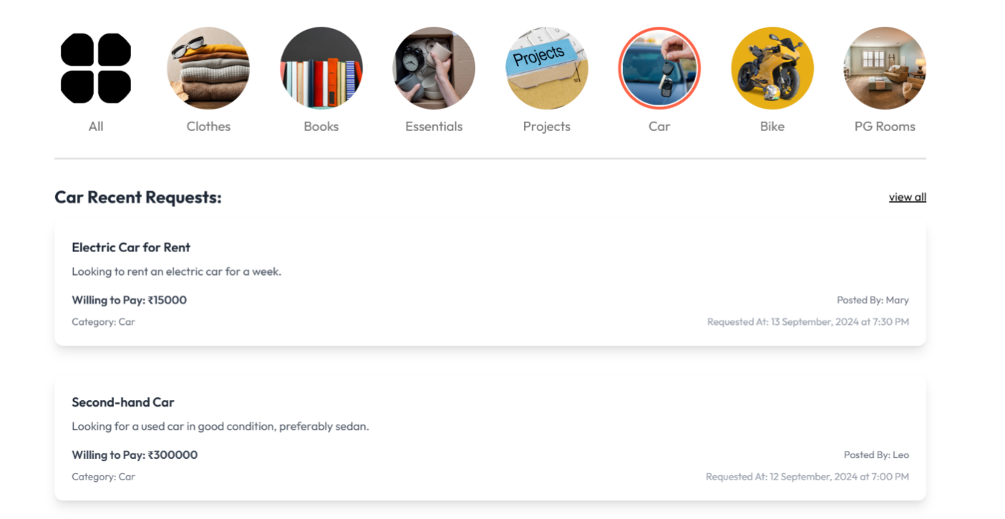

**/category/projects → Category Item: Projects**

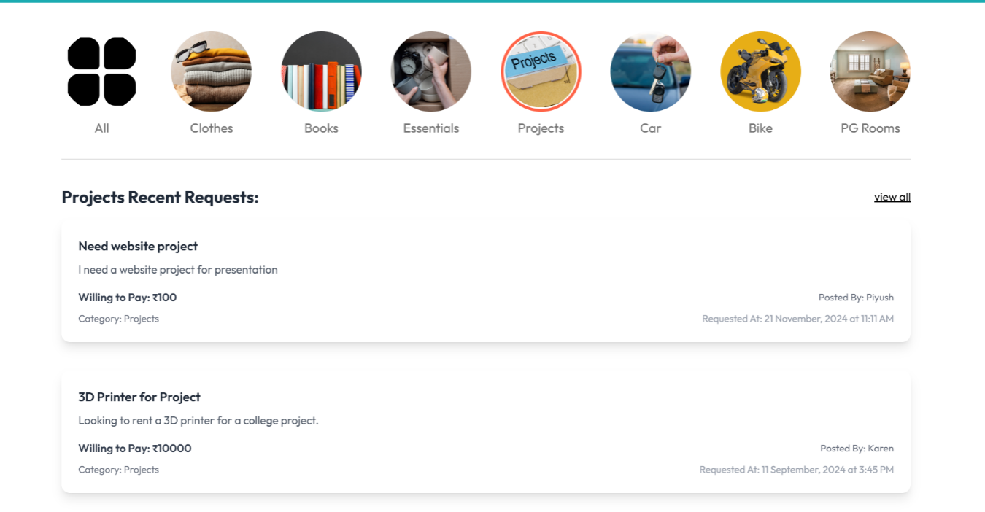

**/category/pg-rooms → Category Item: Pg Rooms**

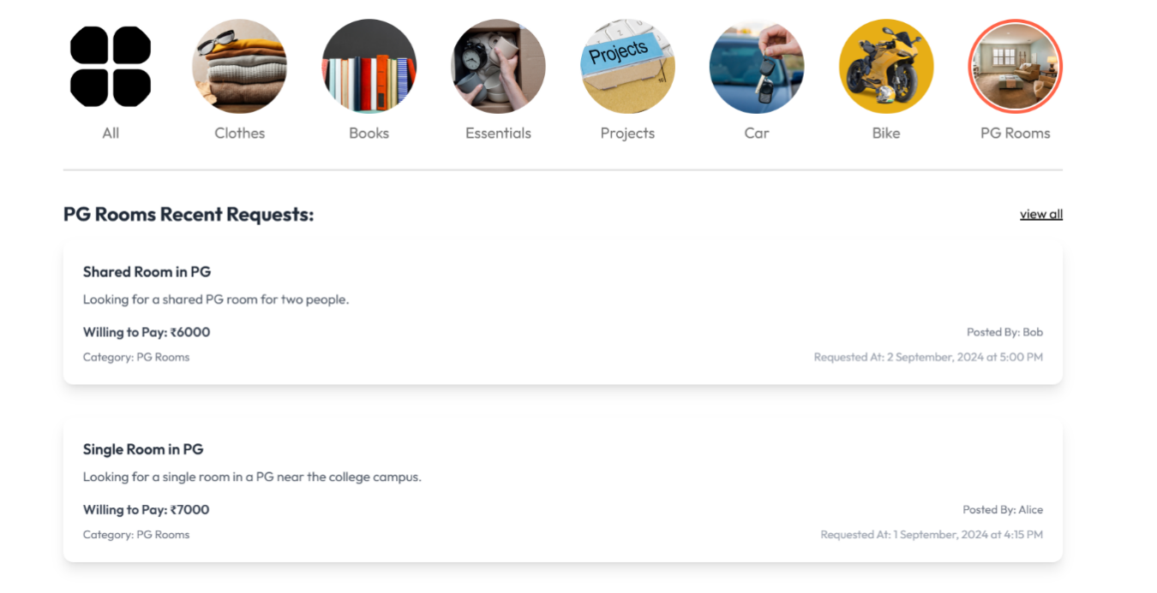

**/category/daily-use → Category Item: Daily Use**

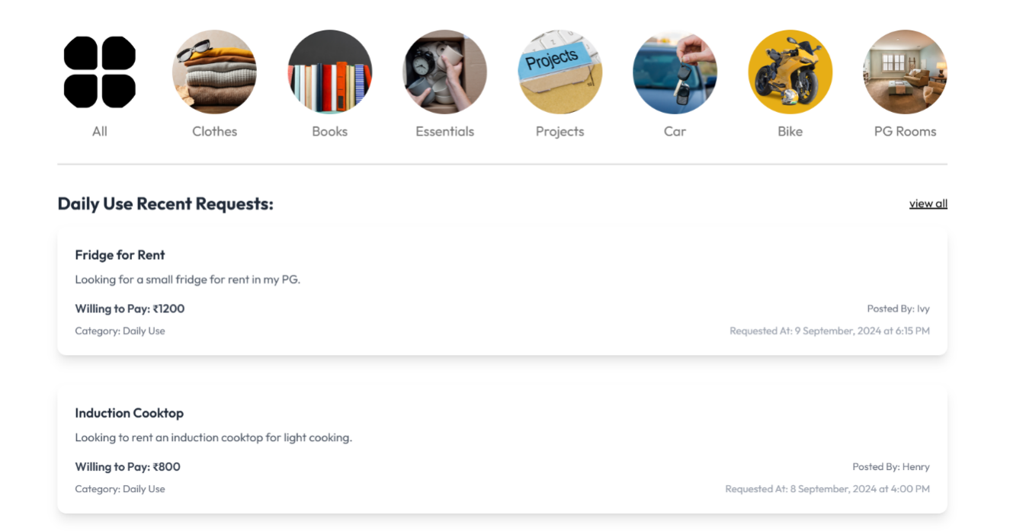

**/category/books → Category Item: Books**

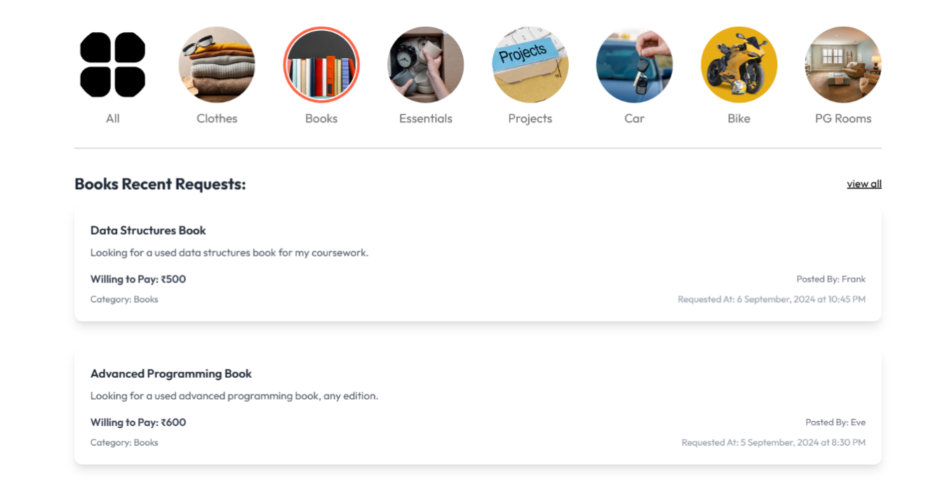

**Transaction Report**

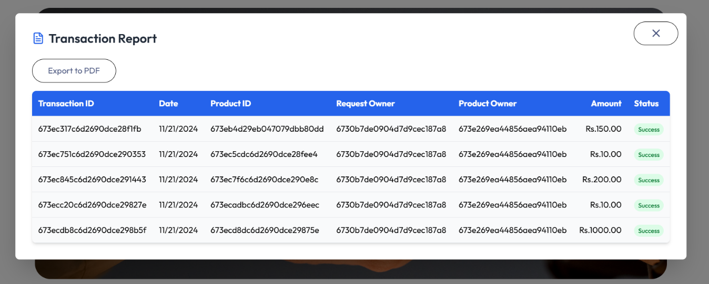

**3.1.1.3 Responsive Design**

* Utilizes **CSS frameworks** like Bootstrap or Material-UI for responsiveness.
* Ensures compatibility across devices, including desktops, tablets, and mobiles

**3.1.1.4 API and Data Handling**

Axios is used for handling API requests to the backend server.

Data Fetching:

GET: Fetch product listings, user data, and transaction history,

POST: User registration, login, and product uploads.

PUT: Update product availability and user profiles.

DELETE: Remove listed products.

The frontend architecture of Project Jugaad is designed to ensure scalability, maintainability, and an engaging user experience. By leveraging modern tools like React.js, Context API, and responsive design principles, the platform provides a seamless and accessible interface for users across all devices.

#### **3.2 Backend Architecture**

The backend architecture of Project Jugaad ensures scalability, security, and efficient handling of requests. Built using **Node.js** and **Express.js**, the architecture focuses on modularity, reliability, and integration with a MongoDB database for managing dynamic data. This backend serves as the foundation for managing authentication, user interactions, product listings, and transactions.

**3.2.1 Core Components of the Backend Architecture**

**3.2.1 Modular Structure**  
The backend is structured into distinct modules for better organization, maintenance, and scalability. Each module handles a specific aspect of the application.

**3.2.2. RESTful API Design**

* The backend provides a set of RESTful APIs to interact with the frontend.
* **HTTP Methods**:
  + **GET**: Retrieve data (e.g., products, user profiles, rental history).
  + **POST**: Create new resources (e.g., add a product, register a user).
  + **PUT**: Update existing resources (e.g., edit product details, update profile).
  + **DELETE**: Remove resources (e.g., delete a product listing).

**3.2.3 Middleware**  
Custom middleware is used for tasks such as:

* Request validation (e.g., validating input data).
* Authentication and authorization (using JWT).
* Error handling (centralized error management).

**3.2.4. Backend Technology Stack**

**3.2.4.1 Programming Language**

* **Node.js**: Handles asynchronous operations efficiently, making it suitable for real-time applications.

**3.2.4.2 Framework**

* **Express.js**: A lightweight and flexible framework for building RESTful APIs.

**3.2.4.3 Database**

* **MongoDB**: NoSQL database for dynamic, document-based data storage.

**3.2.4.4 Authentication**

* **JWT (JSON Web Tokens)**: For secure user authentication.

**3.2.4.5 External Libraries**

* **bcrypt**: Hashes passwords for secure storage.
* **dotenv**: Manages environment variables.
* **mongoose**: Simplifies database operations with MongoDB.
* **cloudinary**: Handles image uploads and storage.

The backend architecture of Project Jugaad is designed to be secure, modular, and scalable. With its robust Node.js and Express.js framework, efficient MongoDB database management, and secure authentication mechanisms, the backend ensures a seamless, reliable, and secure foundation for the platform. This architecture is capable of supporting future enhancements, including real-time updates and third-party integrations.

User Feedback Summary Table:

|  |  |  |
| --- | --- | --- |
| **Feedback Aspect** | **Positive Feedback** | **Negative Feedback** |
| Ease of Use | Intuitive design, easy navigation | Initial learning curve for new users |
| Performance | Fast response times and minimal latency | Occasional slowdowns during peak hours |
| Feature Availability | Useful features for rentals and product sharing | Limited advanced search filters |
| User Interface (UI) | Attractive and modern design | Minor bugs in mobile responsiveness |
| Security | Secure authentication process | No two-factor authentication |
| Reliability | Consistent uptime | Downtime during maintenance |
| Customer Support | Helpful and responsive team | Limited availability during non-business hours |

**BIBLIOGRAPHY**

**Website Development Resources**

* Duckett, Jon. HTML and CSS: Design and Build Websites. Wiley, 2011.
* Duckett, Jon. JavaScript and JQuery: Interactive Front-End Web Development. Wiley, 2014.

**Database and Backend Development**

* Welling, Luke, and Laura Thomson. PHP and MySQL Web Development. Addison-Wesley, 2008.
* Murach, Joel. Murach's MySQL. Mike Murach & Associates, 2012.

**Authentication and Security**

* Garfinkel, Simson. Web Security, Privacy & Commerce. O'Reilly Media, 2002.
* Schneier, Bruce. Applied Cryptography: Protocols, Algorithms, and Source Code in C. Wiley, 1995.

**UI/UX Design**

* Tidwell, Jenifer. Designing Interfaces: Patterns for Effective Interaction Design. O'Reilly Media, 2019.
* Krug, Steve. Don't Make Me Think: A Common Sense Approach to Web Usability. New Riders, 2014.

**Project Management and Development**

* Sommerville, Ian. Software Engineering. Addison-Wesley, 2015.
* Pressman, Roger S. Software Engineering: A Practitioner's Approach. McGraw-Hill Education, 2014.

**Open-Source Tools and References**

* Official documentation of Bootstrap: <https://getbootstrap.com>
* Official documentation of React.js: <https://reactjs.org>
* MySQL Documentation: <https://dev.mysql.com/doc/>

**Additional References**

* Mozilla Developer Network (MDN) Web Docs: <https://developer.mozilla.org>
* W3Schools: <https://www.w3schools.com>

**CONCLUSION**

The **Project Jugaad** platform is an innovative solution tailored exclusively for KIETians. It enables them to share and rent items within a trusted community. By allowing users to post listings on their profiles, the platform simplifies the process of connecting students with the resources they need, fostering a sense of mutual support and collaboration.

This project not only addresses common challenges faced by students, such as limited budgets and accessibility to essential items, but also promotes sustainability by encouraging the reuse of resources. The secure and user-friendly interface ensures a seamless experience, making it easy for students to interact and exchange items.

Through **Project** **Jugaad**, we aim to build a resourcefulness and community bonding culture, empowering students to make the most out of their campus life. With potential for future enhancements like rating systems, advanced search options, and integrated payments, the platform is poised to become an indispensable tool for the KIET community.